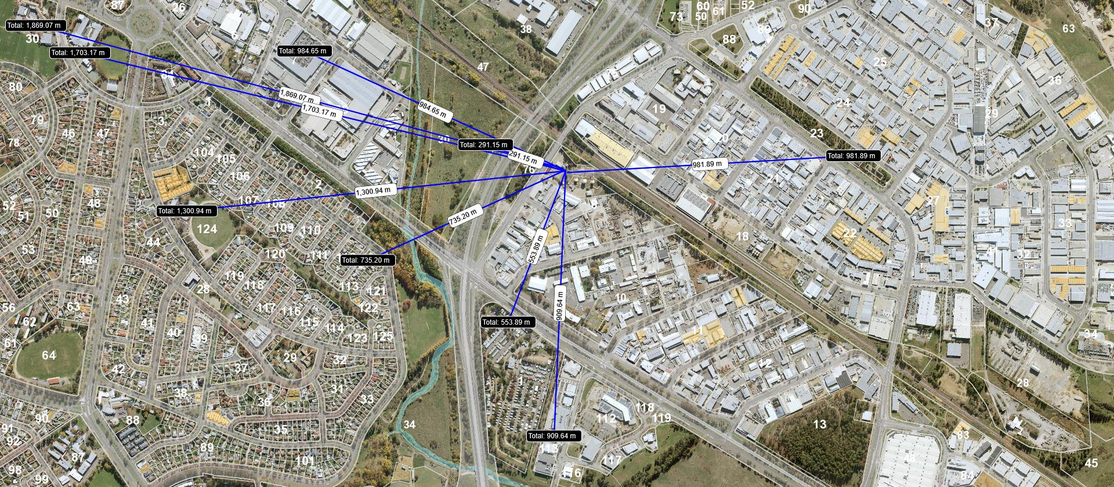 Location of proposed ActewAGL/Capital Recycling Solutions (CRS) Waste to Energy facility on Section 8 Blocks 9 and 11 Division of Fyshwick, IZ2 - Industrial mixed use zone. The following uses show distances from the site of the proposed ActewAGL/CRS waste facility (IZ2 Mixed Use Industrial Zone (pdf)-pages 2, 3) Incineration facility is a PROHIBITED DEVELOPMENT at this IZ2.
- Section 30 in the East Lake draft Planning Report (EPSDD website) on page 70 indicates with reference to d-Monaro highway Mixed-Use that development up to six storeys to Monaro Highway with ground floor retail, restaurant, shop-front services and first floor and above for office, commercial services and/or residential is planned. The distance of this future development, most likely to include substantial residential, is to be located less than 300m from the proposed incineration facility. The IZ.1 zone requires variation for East Lake to proceed.
- Section 30 , Blocks 8 and 11 currently IZ.1- General Industrial Zone allows development including hazardous industry, hazardous waste facility, incineration facility, offensive industry, MAJOR UTILITY INSTALLATION, railway use, recyclable materials collection, recycling facility, transport depot, waste transfer station. p.2 (IZ1 General Industrial Zone(pdf)) but IZ.2 does not.
- The long stay residential village on Canberra Ave adjacent the Monaro Hwy is unzoned but only 554m from the proposed CRS waste facility.
- Residential Narrabundah commences within 735m of the proposed CRS waste facility.
- The Symonston Childcare Centre is 910m from the proposed CRS waste facility.
- The Childcare Centre accommodating children with illnesses and special health and other needs is located 982m from the proposed CRS waste facility.
- The Fyshwick open fresh food market is 985m from the proposed waste facility. Schools in Narrabundah and at Hume Circle are 1.3km, 1.7km and 1.9km from the waste incinerator.
- The residential suburbs of Central Canberra are located in a valley where inversion is an issue as evidenced in a recent burn off at Kowen Forest. Canberra Airport is less than 3km away.
- ACT Government Environment Protection Agency - Draft Separation Distance Guidelines for Air Emissions (November 2014) states a distance of 500m from an incineration facility (see page 9) for sensitive land uses such as listed on page 5. eg. Residential, caravan park, parklands, educational establishments, childcare centres, hotels, motels, tourism accommodation etc.

