Residents rail against Fyshwick recycling plant 2-6-18

By Katie Burgess
Leave a comment
Inner south Canberra residents say a recycling plant proposed for the city's east will cause odour and traffic problems for people living hundreds of metres away.
Capital Recycling Solutions wants to build the materials recycling facility on Ipswich Street in Fyshwick.
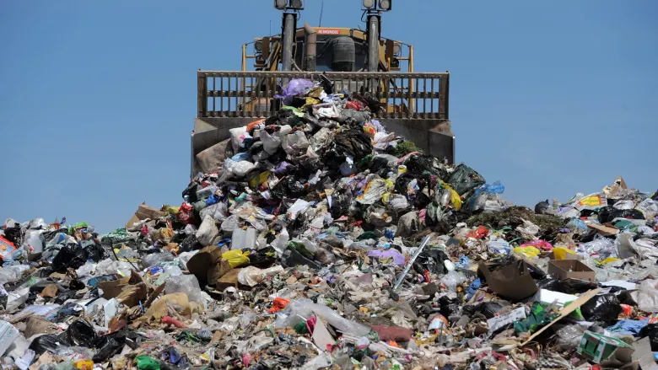 The Mugga Lane landfill, photographed in 2012. A proposed recycling plant could see 900 tonnes of rubbish diverted from the tip per day. Photo: Graham Tidy
The company has postponed its proposal for a waste-to-power plant on the same site, citing community concern.
The rubbish-burning plant received a drubbing at a community council meeting last year.
Now the same group of residents say the recycling plant will negatively impact people living on East Lake 300 metres away, and in Narrabundah 600 metres away.
Advertisement
The plant would divert rubbish from Canberra's red bins to Fyshwick, and is expected to receive an average of 900 tonnes of rubbish a day, 12 hours a day, 6.5 days per week.
There'd be an extra 230 truck movements a day, with waste arriving across a 16-hour window.
At an Inner South Canberra Community Council meeting on Thursday night, close to 100 residents voted overwhelmingly to oppose the proposal.
Leo Dobes from the Griffith Narrabundah Community Council said he had concerns with the modelling used for the environmental impact statement.
"The modelling for odour was based on three separate models, American models, some of the parameters used were American. It's not clear how much local data was used, wind factors and everything would have to be local but usually it's just averages over the whole year. It's possible you would get the occasional smell that would affect people that can't be modelled," Dr Dobes said.
"The people who did the odour report can't tell what will happen at this stage because no one knows what level of putrescible waste will be used and what the volume will be. The index says until that's established they can't really tell what will happen so they've qualified their report."
Dr Dobes also said the traffic modelling did not estimate delays along Ipswich and Willuna Streets due to extra trucks and should have been measured at midday - Fyshwick's traffic peak.
"What's really important is the extra time it will take to get up Ipswich Street," he said.
Public consultation on the plant's environmental impact statement has been extended to June 27.
https://www.canberratimes.com.au/politics/act/residents-rail-against-fyshwick-recycling-plant-20180601-p4zivt.html

